Project Synopsis
on
E-Portal for facilitating Case Management Hearing of various types of cases
Submitted as a part of course curriculum for
Bachelor of Technology
in
Computer Science


Submitted by
Aaditiya Tyagi 2200290120001
Akash Tiwari 2200290120016
Akshat Jain 2200290120019
Ankit Chaudhary 2200290120032

Under the Supervision of
Prof. Anmol Jain
(Assistant Professor Department of Computer Science)
Signature:
KIET Group of Institutions, Ghaziabad
Department of Computer Science
Dr. A.P.J. Abdul Kalam Technical University
Abstract
This project proposes an innovative digital platform to transform the traditional manual case management system. The E-Portal for Case Management Hearing and Facilitation of Legal Proceedings digitizes legal processes, ensuring accessibility, transparency, and efficiency for litigants, lawyers, judges, court staff, and administrators. It streamlines case filing, hearing scheduling, and document tracking while integrating automated notifications and advanced security protocols. The portal fosters pre-hearing dispute resolution and provides tools for data analysis to enhance decision-making. This project aims to revolutionize the judicial system by reducing case backlogs and ensuring timely justice through modern technology.

Introduction
Traditional court systems are bogged down by manual processes, resulting in inefficiencies, delays, and limited access to justice. This project aims to address these issues by developing an online platform to automate case management and hearings. By leveraging technology, the proposed system ensures seamless interaction between all stakeholders, minimizing paperwork and procedural delays.

Review of Existing System / Literature Review
Existing systems rely heavily on in-person interactions, leading to significant backlogs and inefficiencies. Attempts to digitize have been limited to basic filing systems without comprehensive features such as automated notifications, pre-hearing settlements, and role-based access. This project bridges these gaps by creating a unified platform with robust functionality, advanced analytics, and secure data handling.

Problem Statement
The current judicial process suffers from delays caused by manual workflows, lack of transparency, and difficulty in tracking case progress. These inefficiencies lead to delayed justice, impacting litigants and legal professionals alike. A comprehensive digital solution is needed to streamline processes and improve accessibility.

Objectives
- To automate the case filing and management process.
- To provide role-based access ensuring secure and transparent user interactions.
- To introduce automated alerts for hearing schedules and updates.
- To enable pre-hearing dispute resolutions to reduce formal proceedings.
- To integrate data analysis tools for monitoring trends and improving decisions.

Proposed System
The proposed E-Portal digitizes case management and legal proceedings, offering features such as:
- User authentication and role-based access.
- Automated case submission and tracking workflows.
- Pre-hearing settlement modules.
- Document management and validation.
- Automated alerts and notifications.
- Tools for data analysis and reporting.
Methodology
Implementation Activities:
- Development of the user interface using React, Vanila CSS , JWT,.
- Backend development with Node.js for managing workflows.
- Database design using MongoDB.
- Implementation of security measures such as SSL encryption and audit trails.
- Integration of analytics tools for data-driven insights.
ER-Diagram
The database includes entities such as Users, Cases, Documents, Hearings, and Notifications, with relationships ensuring efficient data management.
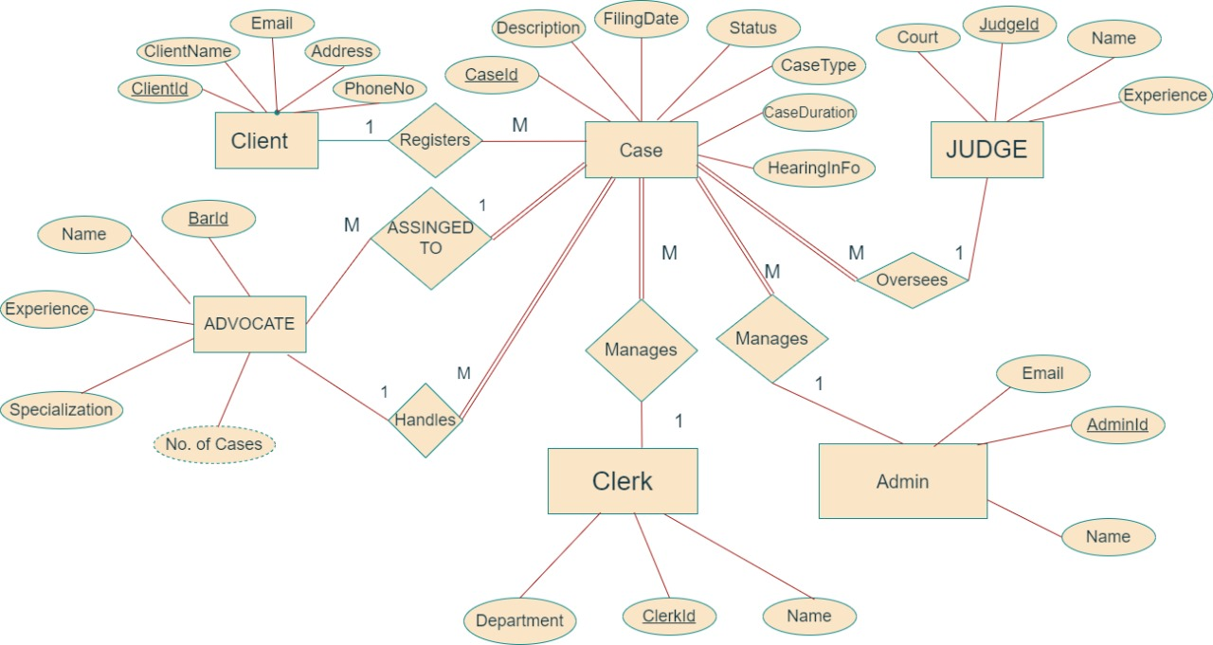
Fig:-1.0 ER Diagram
Proposed-Algorithm
Case workflows will utilize priority-based scheduling algorithms to manage hearings and notifications efficiently.

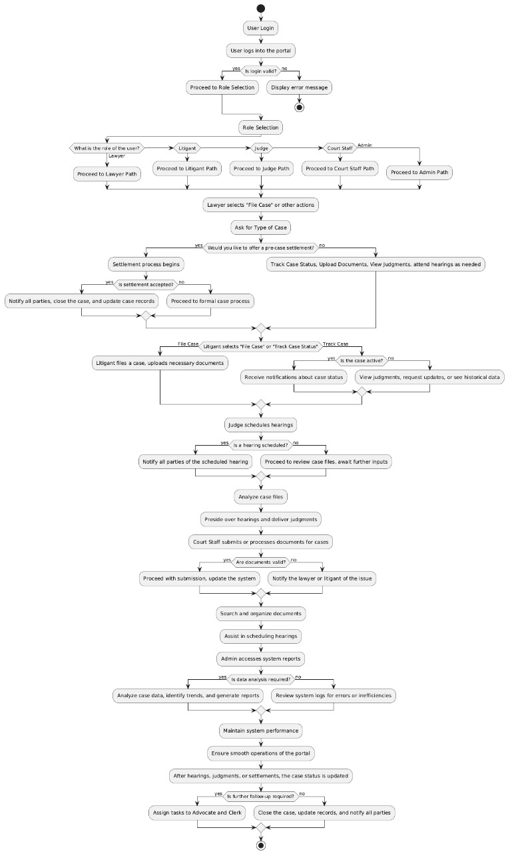
Fig:-1.1 Flow Chart
Technology/Tools Used
- Frontend: React, Vanila CSs
- Backend: Node.js
- Database: MongoDB
- Security: SSL/TLS Encryption, Role-Based Access Control
- Analytics: Data visualization tools for performance tracking

Expected Outcomes
- Reduction in case backlog through automation.
- Improved accessibility and transparency for litigants and legal professionals.
- Enhanced decision-making with data-driven insights.
- A secure and user-friendly platform that complies with legal regulations.

Conclusions
The E-Portal for Case Management Hearing and Facilitation of Legal Proceedings addresses long-standing inefficiencies in the judicial process by leveraging technology to automate workflows, ensure transparency, and enhance accessibility. This project promises to streamline legal proceedings and promote timely justice.

Gantt Charts / Timeline Schedules
A detailed Gantt chart outlining key milestones such as requirement gathering, system design, development, testing, and deployment will be included.

References
- M. A. H. Al-Farsi and R. A. M. Al-Khalidi, "A Review on Case Management Systems for E-Governance," Journal of Computer Science and Technology, vol. 15, no. 3, pp. 412-423, Jul. 2018.
- K. J. Cios and G. W. H. Liu, Data Mining: A Knowledge Discovery Approach. New York, NY, USA: Springer, 2020.
- C. S. Tang and J. L. Smith, "Design and Development of an E-Case Management System for Legal Studies," International Journal of Information Management, vol. 35, no. 4, pp. 456-463, Aug. 2019.
- D. K. Pustokhina and S. A. Zhdanova, "Information Systems in the Judicial Sector: An Overview," Proceedings of the 2019 International Conference on Information Systems and Design of Communication, pp. 93-99, Sep. 2019.
  - N. Bhardwaj, "Security Considerations in E-Governance Systems,“
- IEEE Access, vol. 9, pp. 11234-11246, Feb. 2021.

